Name = Stephen Centre Number = 23215

1. The grid shows several transformations of the shaded triangle.
x
y
O
5
4
3
2
1
–1
–2
–3
–4
–5
–4
–3
–2
–1
1
2
3
4
5
A
B
C
D
E
F
H
G
(a) Write down the letter of the triangle
after the shaded triangle is reflected in the line x = 3,
C
Answer ............................................
(1)
(b) Describe fully the single transformation which takes triangle F onto triangle G.
Reflection
...............……………………………………………………………………………..
(2)
(Total 5 marks)
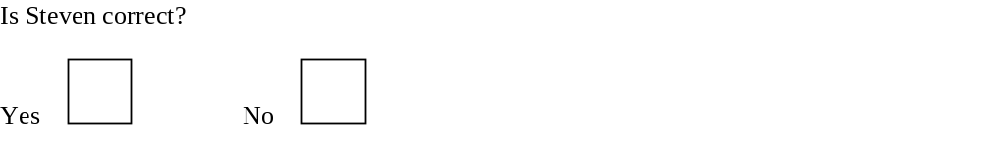
Part a
Part b
Is Stephen correct?
Is Stephen correct?
Yes
No
Reason why?
…………………………………………………………………………………………………………….
…………………………………………………………………………………………………………….
…………………………………………………………………………………………………………….
…………………………………………………………………………………………………………….

2. Triangle A is drawn on the grid below.
O
y
x
4
3
2
1
–1
–2
–3
–4
–4
–3
–2
–1
1
2
3
4
A
Reflect triangle A in the x-axis.
Label the triangle B.
(1)
(Total 3 marks)

Is Stephen correct?
Yes
No
Reason why?
…………………………………………………………………………………………………………….
…………………………………………………………………………………………………………….

4. Draw the reflection of the shape in the mirror line.
Mirror Line
(Total 2 marks)
Is Stephen correct?
Yes
No
Reason why?
…………………………………………………………………………………………………………….
…………………………………………………………………………………………………………….

3. The diagram shows a triangle drawn on a centimetre square grid.

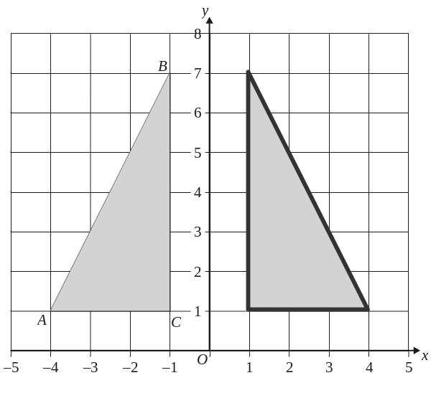

(a) Write down the coordinates of A.
-4 , 1
Answer A (……………. , ……………)
(1)
(b) Draw the reflection of the triangle in the y-axis.
(2)
(Total 3 marks)
Is Stephen correct?
Yes
No
Reason why?
…………………………………………………………………………………………………………….
…………………………………………………………………………………………………………….
…………………………………………………………………………………………………………….
…………………………………………………………………………………………………………….

5.
–6
–5
–4
–3
1
2
3
4
5
6
x
y
5
4
3
2
1
–1
–2
–3
–4
–5
A
B
–2
–1
O
Describe the transformation that maps triangle A to triangle B.
Relfection
.....................................................................................................................................
.....................................................................................................................................
.....................................................................................................................................
(2)
Is Stephen correct?
Yes
No
Reason why?
…………………………………………………………………………………………………………….
…………………………………………………………………………………………………………….

